Project Design Phase-II
Technology Stack (Architecture & Stack)
Date | 15 july 2026
Team ID | SWTID-2026-9567
Project Name | AI Powered Debt Relief & Financial Recovery Platform
Maximum Marks

Technical Architecture

The FinRelief AI platform follows a modular three-tier architecture consisting of a responsive web interface, FastAPI backend, AI engine, and database. Users securely access the application through a web browser, where financial data is processed by the backend and analyzed using Google Gemini AI to generate personalized debt recovery recommendations.

Architecture Diagram (Simplified)

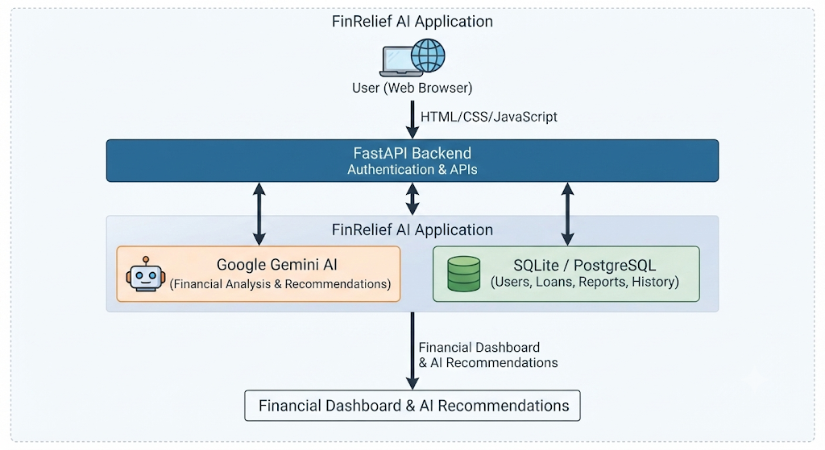

Table 1: Components & Technologies
S.No | Component | Description | Technology
1 | User Interface | Web interface for user interaction | HTML5, CSS3, JavaScript
2 | Application Logic-1 | User authentication and financial processing | Python, FastAPI
3 | Application Logic-2 | Financial analysis and debt management | Python
4 | Application Logic-3 | AI-powered recommendations and settlement guidance | Google Gemini 1.5 Pro API
5 | Database | Stores user, loan, and financial records | SQLite / PostgreSQL
6 | Cloud Database | Future cloud database support | PostgreSQL Cloud / Firebase
7 | File Storage | Stores reports and application files | Local File System
8 | External API-1 | AI recommendation service | Google Gemini API
9 | External API-2 | Authentication and secure API access | JWT Authentication
10 | Machine Learning Model | AI model for financial analysis and recommendations | Google Gemini 1.5 Pro
11 | Infrastructure | Local deployment with future cloud support | Uvicorn, Local Server, AWS/Azure/GCP Ready

Table 2: Application Characteristics
S.No | Characteristic | Description | Technology
1 | Open-Source Frameworks | Frameworks used for application development | FastAPI, SQLAlchemy, Python
2 | Security Implementations | User authentication, encrypted passwords, secure APIs | JWT, Password Hashing, HTTPS
3 | Scalable Architecture | Modular three-tier architecture supporting future expansion | FastAPI, REST APIs
4 | Availability | Reliable backend services and database connectivity | Uvicorn, SQLite/PostgreSQL
5 | Performance | Fast API response, optimized database queries, efficient AI processing | FastAPI, SQLAlchemy, Uvicorn

Technology Stack Summary

- Frontend: HTML5, CSS3, JavaScript
- Backend: Python 3.11+, FastAPI
- AI Model: Google Gemini 1.5 Pro API
- Database: SQLite / PostgreSQL
- Authentication: JWT
- Server: Uvicorn
- IDE: Visual Studio Code
- Version Control: Git & GitHub

